create database student;

use student

create table customer(cid int primary key, cust_name varchar(30), city varchar(20), grade int, saleman_id int);

insert into customer(cid, cust_name, city, grade, saleman_id)values(1001, 'Nick rimando', 'New York', 100, 5001);

insert into customer(cid, cust_name, city, grade, saleman_id)values(1002, 'Brad Davis', 'New York', 200, 5001);

insert into customer(cid, cust_name, city, grade, saleman_id)values(1003, 'Ghraham Juisy', 'Calafornia', 200, 5002);

insert into customer(cid, cust_name, city, grade, saleman_id)values(1004, 'Lulin Green', 'London', 300, 5002);

insert into customer(cid, cust_name, city, grade, saleman_id)values(1005, 'Fabian Johnson', 'Paris', 300, 5006);

insert into customer(cid, cust_name, city, grade, saleman_id)values(1006, 'Geoff Germon', 'Berlin', 100, 5003);

insert into customer(cid, cust_name, city, grade, saleman_id)values(1007, 'Jocy Jack', 'Moscow', 200, 5007);

insert into customer(cid, cust_name, city, grade, saleman_id)values(1008, 'Brad', 'London', 100, 5005);

select *from customer;

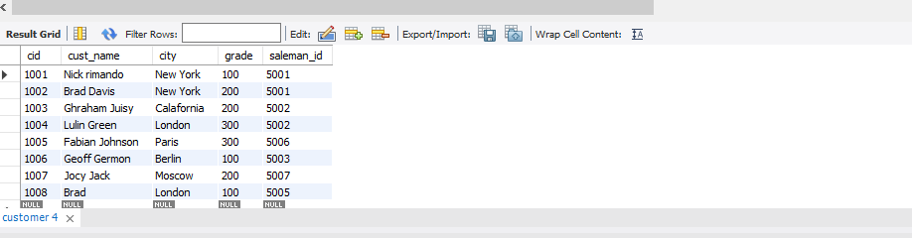

insert into saleman(sid, saleman_name, city, comission)values(101,'James Hook','Newyork', 0.15);

insert into saleman(sid, saleman_name, city, comission)values(102,'Nail Knif','Paris', 0.13);

insert into saleman(sid, saleman_name, city, comission)values(103,'Pit Alex','London', 0.12);

insert into saleman(sid, saleman_name, city, comission)values(104,'Mc Loyn','Paris', 0.11);

insert into saleman(sid, saleman_name, city, comission)values(105,'Paul Adam','Sanjohn', 0.14);

insert into saleman(sid, saleman_name, city, comission)values(106,'Lausom Hen','Rome', 0.13);

select *from saleman;

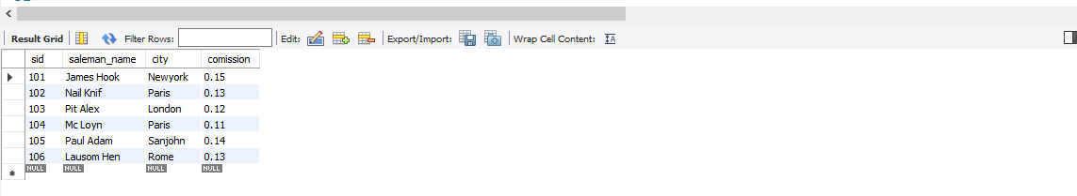

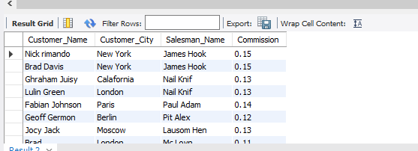

SELECT

customer.cust_name AS Customer_Name,

customer.city AS Customer_City,

saleman.saleman_name AS Salesman_Name,

saleman.comission AS Commission

FROM

customer

JOIN

saleman

ON

customer.saleman_id = saleman.sid;